



* S**olve for Price** = Take inverse of demand fucntion



* **Revenue = P(Q)xQ =>**



* **Marginal Revenue = (derivative of Revenue) =>**
* **Marginal Cost = Derivative Total Cost => *So, (1000+30Q; MC= 30) ***Not for this example***
* **Profit Maximization = (MR=MC) (MC here is given at $20) so…=>**





* **Profit = (Q x P) – (Q x C) =>**
* **Above gives you Quant (Q), now plug into Price formula to get P =>**





* **Use elasticity Formula, fill in random number for (Q), solve for (P) in price function**



* **Add up demand of both =>**



* **Go through same process above with new Demand Function**
* **Get new numbers and solve for Profit. (taking into account $1000 Marketing fee)**





* **We know New York from above, go through whole process for Bay Area (Q=40; P=60)**
* **Profits = ((P)ny x (Q)ny) + (P)ba x (Q)ba) – ((C)ny x (Q)ny + (C)ba x (Q)ba – (fixed Costs)**



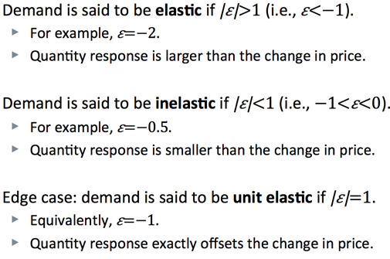

* **Elasticity = (Q1-Q0)/Q(0)**

**(P1-P0)/P0**

* **Cross Price Elasticity = (Qi1-Qi0)/Qi(0)**

**(Pj1-Pj0)/Pj0**



* **% Change in Quant = Price Elasticity x % Change Price**
* **CHANGE DEMAND CURVE=> Change entire demand curve when EXTERNAL prices change. Just move along same demand Curve when INTERNAL price changes.**

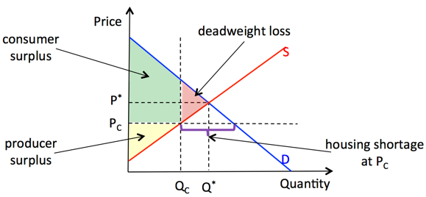

* **CS= WTP-Price**
* **PS= Price-WTS**
* **CS+PS= WTP-WTS = Total Surplus**

**(Y1-Y0)/Y0**

* **Income Elasticity = (Q1-Q0)/Q(0)**
* **Variable Cost= Total Costs- fixed Costs**
* **Average Cost= Total Cost/ Quantity**
* **Fixed Costs= Cost is Quant is 0**

