**Common Size Income:** All income statement lines expressed as a **percentage of total Revenue.**

Removes “scale” effects, Compare company with itself or other companies

**Common Size Balance Sheet:** All balance sheet lines expressed as a **percentage of total Assets.**

**Gross Profit=** Total Revenue- COGS

**Gross Margin (%)=** Gross Profit/ Total Revenue

**Operating Profit (Operating Income) (EBIT) ($)=**Total Revenue- COGS- Total Operating Expenses

**Operating Margin (%)=** Operating Profit/ Total Revenue

Measures core business profitability

Higher Gross Margin is better (Manufacturing Efficiency)

EX: Buy product $1, Sell $2 (rev= $2, COGS= $1; Gross Prof.= $2-$1=1

GM%= Gross Prof./ Rev =$1/2 = 50%

**Earnings Before Taxes (EBT) (Income before Income Taxes):** Total Revenue- COGS- Total Operating Expenses- Interest Expenses (tax expenses not yet subtracted)

**Net Margin (%)=** Net Income/ Total Revenue

**Net Income ($)** Total Revenue- COGS- Total Operating Expenses- Interest Expenses- Tax Expenses

**Effective Tax Rate (ETR)** Tax Expenses *(provisions for Income Taxes)/* EBT

**Working Capital=** Inventory + Accounts Receivable- Accounts Payable(Want negative)

**CAPEX-** Additions to property and equipment, under investing on cash flows.

**Earnings Per Share (EPS)** Net Income/ Total Shares Outstanding

**EBITDA:** earnings before interest, taxes, depreciations, and amortization (EBIT + DA)

**Perpetuity =** NPV= CF1 **/** r

**NPV = Sum of PVs**

**\*\*\*PV is less than FV**

**PV = FV/(1+r)^n**

**FV = PV(1+r)^n**

**Days Payable =** Accounts Payable/Average Daily Cogs (Cogs/365)

**Constant Growth =** NPV= CF1/(r-g)

**Inventory Turnover =** 365/Days Inventory

**Free Cash Flow= CFFO- CapEx**; (*CapEx is under CFFI)* => FCF is how much a company makes after making minimum investment to survive

**Days Inventory=** Is the number of days on average it takes to sell a unit of inventory

\***Days Inventory =** **Inventory Balance** (*Found on Balance Sheet)***/ Average Daily COGS;** or **Inventory Balance / (Yearly COGS / 365 Days);** or **Inventory Balance /(Quarterly COGS / 91 Days)**; \*\*\***Lower Days Inventory is Better\*\*\***

**Days of Sales Outstanding (DSO)=** Is the number of days on average it takes to collect cash from a customer

\***DSO=** **A/R Balance** (*Found on Balance Sheet)***/ Average Daily Revenue;** or **A/R Balance / (Yearly Rev/ 365 Days);** or **A/R Balance /(Quarterly Rev/ 91 Days)**; \*\*\***Lower DSO is Better\*\*\***

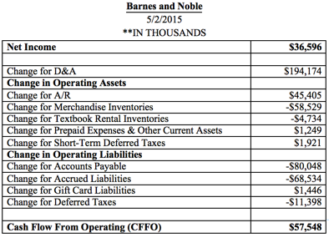

**Net Income to CFFO**

Start with Net Income (from the Income Statement)

1. (+) Add back **Non Cash Expenses** (Depreciation of PP&E; amortization of intangibles; stock-based compensation)

Using the Balance Sheet with **two dates** (two columns)

1. (+) Add back however much **operating assets decreased** by (add back any decrease in Inventory, A/R, Prepaid Expenses, Deferred Taxes, etc); do not include cash and short term investments when doing this.
2. (+) Add back however much **operating liabilities increased** by (add back and increases in A/P, Accrued Expenses, Deferred Revenue, Taxes Payable, etc.)
3. (-) Subtract however much operating assets increased
4. (-) Subtract however much operating liabilities decreased

Going back to the Income Statement…

1. (+) Add back **non-cash losses** on sale of assets (equipment or businesses, loss of disposable assets)
2. (-) Subtract non-cash gains on sale of assets

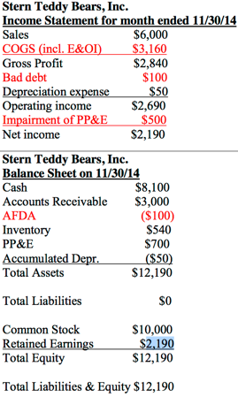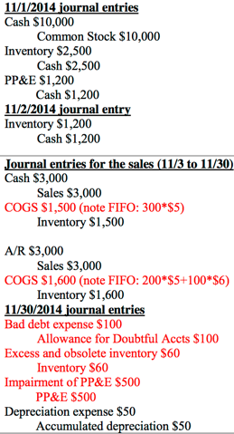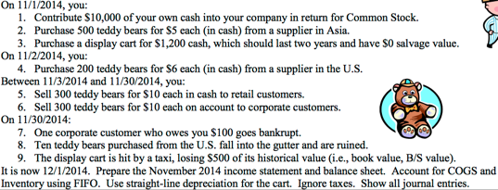



**Sales to Asset Turnover** = Total Revenue / Total Assets (ending balance)

**Net Margin** =Net Income/ Total Revenue

**Return on Assets** = (Net Income / Rev) * (Rev/ Total Assets)

**Return on Assets** = Net Income / Total Assets (ending balance)

**Return on Equity** = Net Income / Stockholder’s Equity (ending balance)

**Return on Equity** = (NI/Rev) * (Rev/TA) * (Financial Leverage)

**Financial Leverage** = Total Assets / Stockholder’s Equity

**Fair Value of a company** = Decided by (1) Returns (2) Growth (3) Risk

**DCF value** = NPV = FCF / r

***Subtract any growth from (r)

**P/S** = Stock Price/ Sales per Share

**Price to earnings** = Stock price / EPS

**Price to Sales** = Market value of equity / total revenue

**Market Value of equity** = Stock Price * Shares out

**P/E** = Market Value of Equity/ Net Income

**Impairment Charge**  = Current Book Value of PP&E – New market value of PP&E

**Shares Outstanding** = Shares Issues- Repurchased

**Treasury Stock** = Repurchased stock

**Market to Book** = Market Value of Equity / Book Value of equity (or Total stockholders equity)

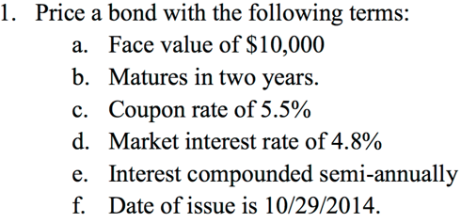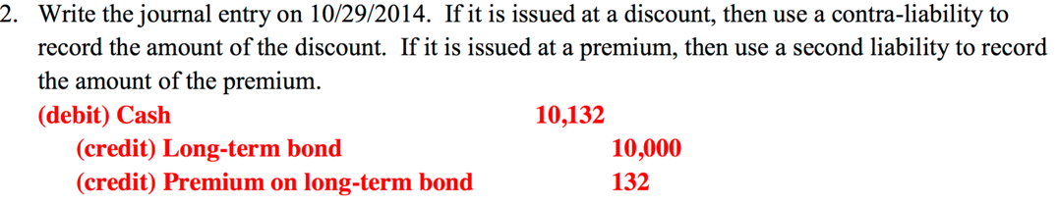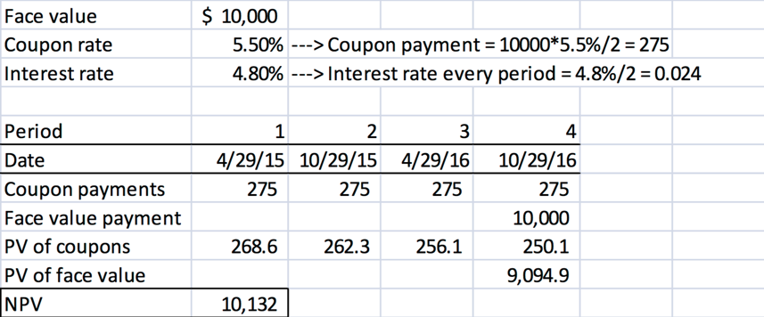

**Bond: Premium**

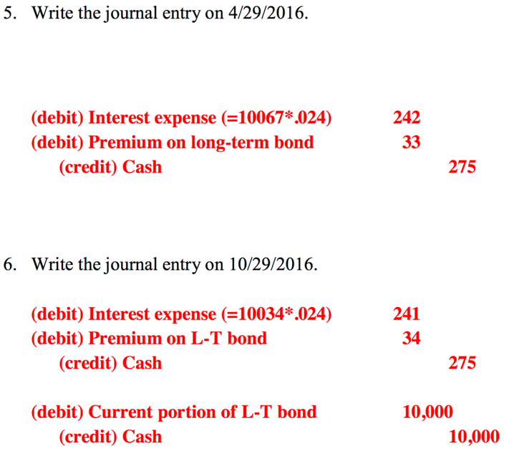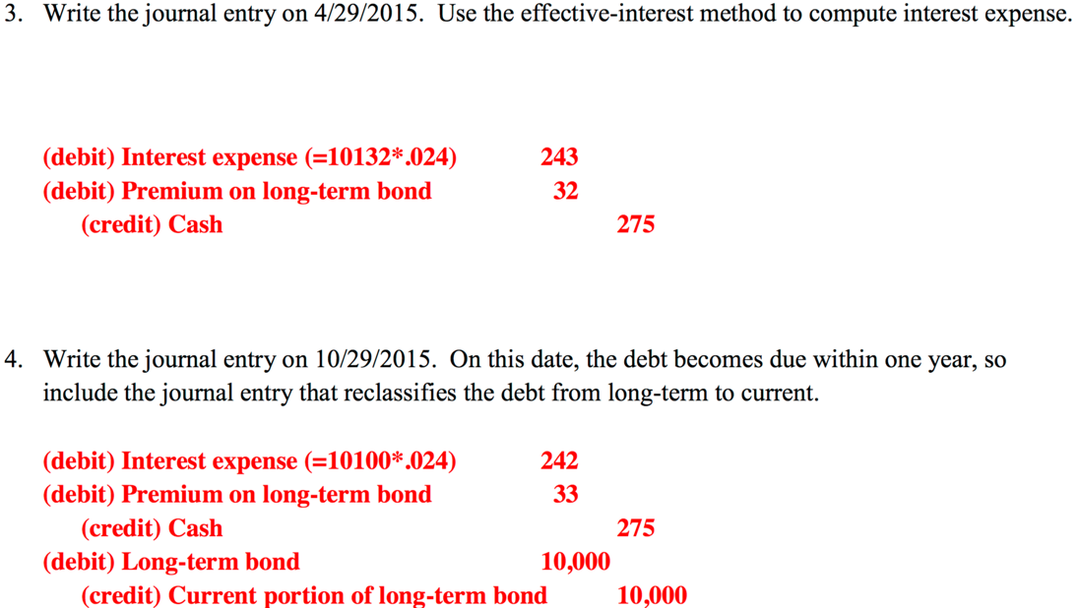

**Bond: Par**

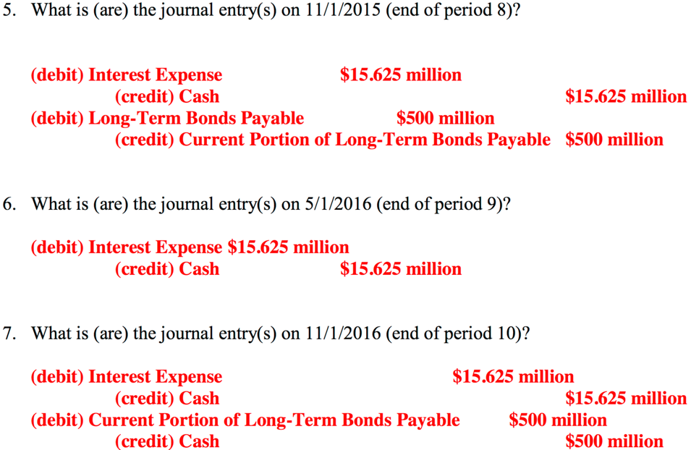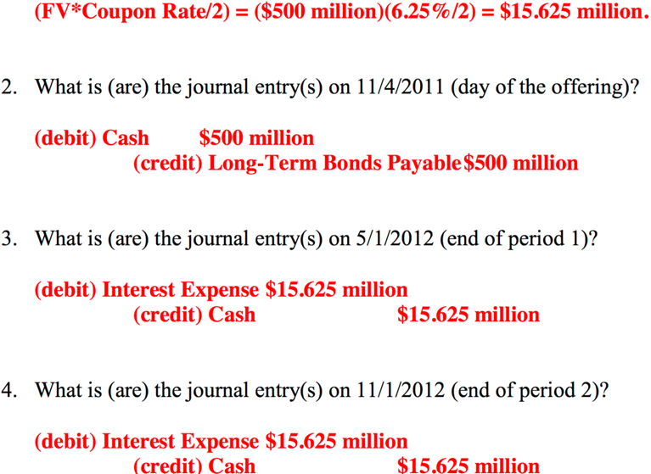

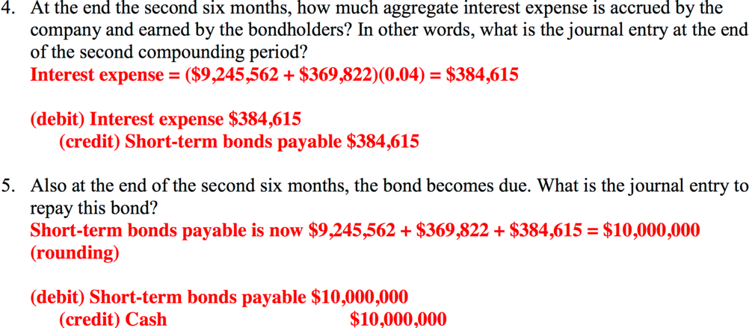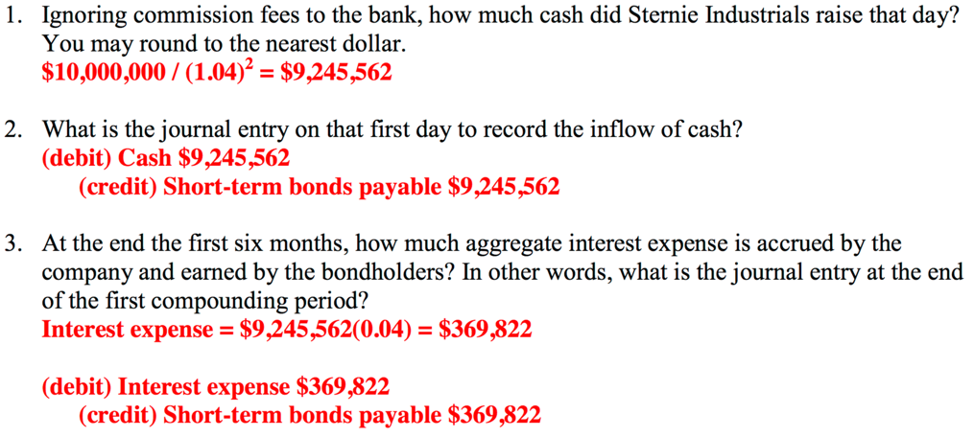

**Bond: No Coupons**

**My Notes of How to do it**

1. **Find PV of Initial Number:** Face Val/(1+ Market Rate/2)^num of times it compounds
2. **Calc individual Coupon rate value:** Face Val (X) Coupon rate/2
3. **Get PV of ALL Coupons=** Coup Rate/(1+ Market Rate/2)^num of times it compounds, repeat
4. **Add ALL Coupon PV to Initial PV to get Total PV**
5. **Debit cash Total PV**
   1. **Credit Short (or Long) Term Bond ORIGINAL NUMBER**
   2. **Credit Premium or DEBIT Discount for the Difference**
6. **Find and Debit interest expense:** Total PV number (X) Market Interest rate/2
   1. **Debit Premium (Or Credit Discount) long term Bond=** Difference between Interest expense and Original Coupon Rate from step 2
   2. **Credit Cash Original Coupon rate from step 2**
7. **Find new interest expense and DEBIT it:** Original NPV – Last difference (step a) (X) Market Interest rate/2
   1. **Debit Premium (Or Credit Discount) long term Bond=** Difference between Interest expense + Original Coupon Rate from step 2
   2. **Credit Cash Original Coupon rate from step 2**

**REPEAT AS NEEDED**

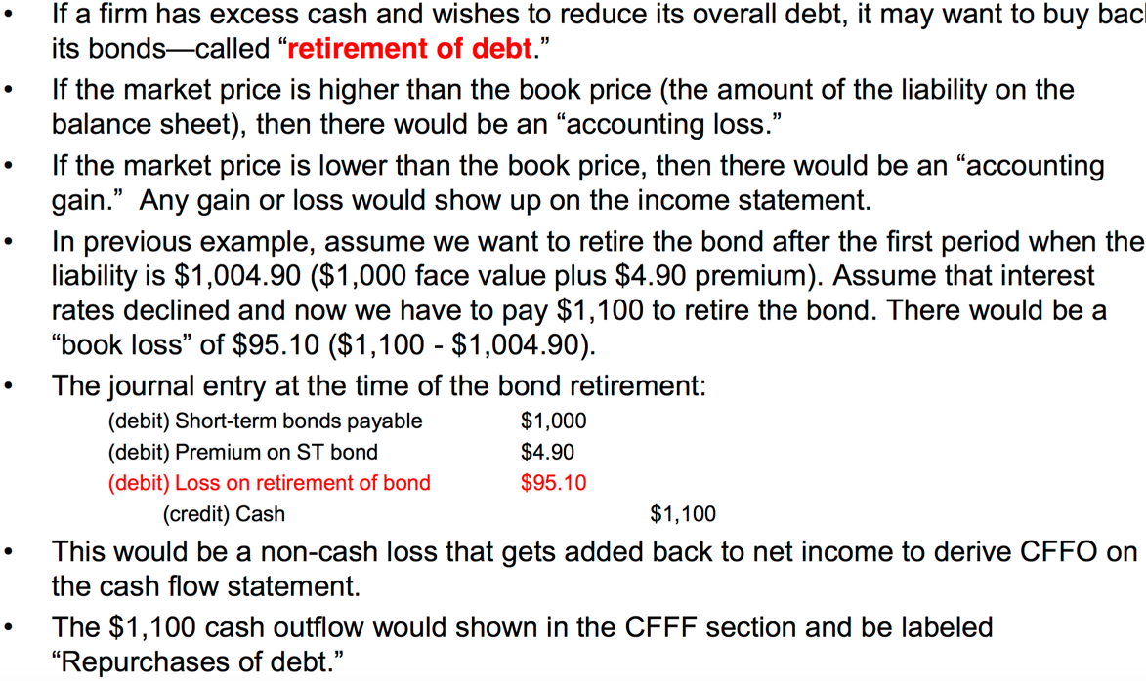

**Premium=** Market rate is LOWER than Coupon

**Discount=** Market rate is HIGHER than Coupon