My Notes: Udacity Lectures: How to Build a Startup The Lean Launchpad

Lesson 1: What we know (11):

1- What we know:
- We have learned Business Plans and old models are not the right path for a Start-up

2- History of the corporation:
- Harvard setup the first MBA class in 1910 to provide managers tools they need to run organizations. IT was really important for the growth of large companies, but there was no curriculum for start-ups
- Start-ups are not smaller versions of bigger companies

3- Startups are NOT smaller versions of corporations:
- Startups SEARCH, large corporations EXECUTE

4- Strategy:
- OLD: Used to believe we create a business plan (ops plan, financial model), execute it, and hard work will make it successful.
- NEW: We now know, no business plan survives first contact with customers. First years of a startup are incredibly unpredictable.
  - Does not mean we should not do any planning.
  - We want to do planning before planning, and before we waste our time on a full business plan. Use Business Model Canvas.
    - Update canvas regularly and use it to test and capture hypothesis.
  - So, Search using the Business Model Canvas for your Business Model. Then when you find it Execute it.

5- Process:
- Used to have this really long, inefficient, expensive, and time consuming process with starting a business. This process is wrong.

6- Waterfall Development:
- The old step-by-step process of development for developing a product. Requirements → Design → Implement → Verify → Maintain. The idea is build on a major fallacy… it assumes you know the problem or need the customer has.
  - This works somewhat in a large company, but not in a startup. Need customer facts first.

7- Customer vs Product Development:
- More startups fail from a lack of customers than from a lack of product development.
- 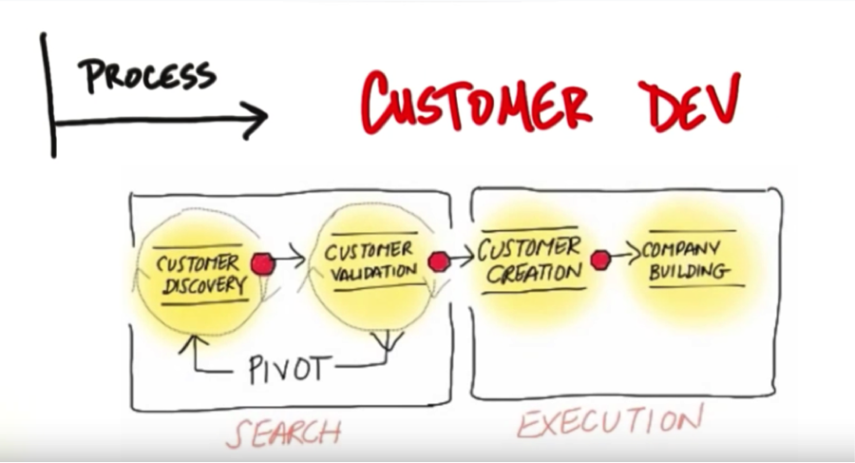
- Agile Development: You want to develop slowly through ITERATIONS. Dont build all at once. Build small portions and test.
- So, the new process is a combination of Customer Development and Agile Development.

8- Quiz for understanding:

9- Organization:
- Functional organizations (top down organizational structure with individual departments) do not work from day one. Wrong
- Need to have a Customer Development Team, run by founders. Founders get out of the building, and you don't need all of the other team members. Founders must spend 20% of time outside of building (don't silo self).

10- Entrepreneurial Education:
- Used to only be about the Execution but now you first need to do Search, before execution. This class will teach you about Search

11- Quiz:

Lesson 1.5: Business Models and Customer Development (11):

1- What is a Company?:
- A business or organization which sells a product or service in exchange for revenue and profit.
  - So, non-profits do not apply to these models
- What is a startup- A startup is a temporary organization designed to Search for a repeatable (Works mon, tues...so on) and scalable (Dollar in, get 2 dollars out) Business Model.

2- Business Model:
- A Business Model is how a company creates value for itself while delivering a product or service to customers.
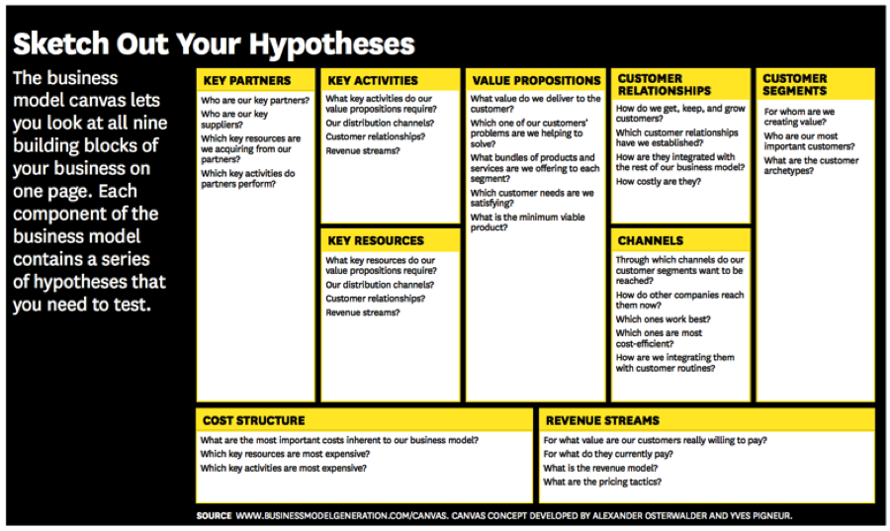

3- Business Model Canvas- Value Proposition:
- What are you building or for whom. What pain are you solving and who are your customers. What product and service are you building. Not just your technology, but what problem or need you are solving
  - Problem: I have an accounting problem, or a word processor problem.
  - Need: Entertainment, I want a date, I want to communicate with friends. (Usually a much bigger Total Available Market TAM).

4- Business Model Canvas- Customer Segments:
- Who are my customers, and why would they buy. You exist for you customers and they don't exist for you. Get out of the office to find these. Can only guess who they are on day 1, will really find out after research in the field.

5- Business Model Canvas- Channels:
- How does your product get to your customer (distribution channels). Can be physical or virtual. (Web, mobile, physical… so on).

6- Business Model Canvas- Customer Relationships:
- How do you get, keep, and grow customers

7- Business Model Canvas- Revenue Streams:
- How are you going to make money? What value is the customer paying for? (Free, Freemium, subscription, licensing… so on). Not, how much you will charge.

8- Business Model Canvas- Key Resources:
- What do you need to make the model work. Capital? Credit? Physical Plant? Patents? Great Programmers…. So on
- What do you need to do to keep these resources/ people.

9- Business Model Canvas- Key Partners:
- Who are your key partners and suppliers? And, what activities are they going to perform and when? (Strategic alliances, joint ventures, suppliers, buyers… so on).

10- Business Model Canvas- Key Activities:
- What are the most important things you need to do to make the business work. Where do you need to be an expert?

11- Business Model Canvas- Costs:
- What are the operating costs to operate the Business Model.
  - What are the most important costs, what are the most expensive resources, what key activities are the most expensive, what are fixed costs, what are variable costs, economies of scale?

Lesson 1.5B: Business Models and Customer Development (18):

1- Hypotheses or Guesses:
- Hypotheses is just guesses. When you fill out the Business Model Canvas, it is just guesses.

2- Customer Development Process:
- Put hypotheses on Business Model Canvas, and then go out and interact with the customers and test it all.
~SEARCH~
- 1.) Customer Discovery: Get out of the building and test your hypotheses to see if other people have the problem or need you think they have.
- 2.) Customer Validation: Does your solution work? (Product Market fit).
~EXECUTION~
- 3.) Customer Creation:
- 4.) Company Building:

3- Quiz:

4- Customer Development Done by Founders:
- Customer dev is done by founders. They have the vision, and the need to be on the ground to understand exactly what is going on. If the founders are there, it creates miscommunication and may stop you from realizing you need to pivot. You have the power to change the product and vision to what is needed.

5- Hypothesis Testing:
- Don't just need data, but can get insights. Change your Business Model Canvas as you discover new things. Run tests to see if you hypothesis works. See why the initial hypotheses work or don’t and then pivot on the BMC.

6- Minimum Viable Product:
- Build the minimum features needed to get feedback. Can be a wireframe, powerpoint, physical product.. So on. Then as you get feedback you can add more features.
  - New market startups you do not necessarily want to ask what features are needed, but you still need to talk to customers to see how your product will change them.

7- Pivot:
- When your hypotheses don’t meet reality, you pivot. Our hypotheses were wrong so we need to change XYZ of what we are building. Change to align. A pivot is more drastic than an iteration.

8- Customer Discover:
- Phase 1: State Hypotheses and draw Business Canvas Model
- Phase 2: Test the Problem
- Phase 3: Test Solution (Build MVP) (Ensure Product-Market Fit)
- Phase 4: Verify or Pivot

9- Quiz:

10- Customer Validation:
- You have product market fit. Now:
  - Phase 1: Get ready to sell- Develop sales, build a high fidelity MVP
  - Phase 2: Get out of the building and do ‘test sales’
  - Phase 3: Develop Positioning, hear what the customers are saying and tweak your sales strategy and positioning.
  - Phase 4: Verify or repeat- Are your ready to start scaling sales or customer creation.

11- Marketing Opportunity Analysis:
- How big is the opportunity. Will you make a million, or a billion?

12- Total Available Market (TAM):
- How big is the entire pie? How many people want or need this product and how large is the market if you got all of it?
- How do you find this:
  - Startup genome project, industry analysis, wall street analysts.
- Served Available Market: How big is my slice of the pie? How many people can and actually will use your product. (how many people have the money, access, so on?)
- How do you find this:
  - Get out of the building and ask. Also research and get really specific in who you exactly will sell to.

13- JerseySquare Market Size:
- 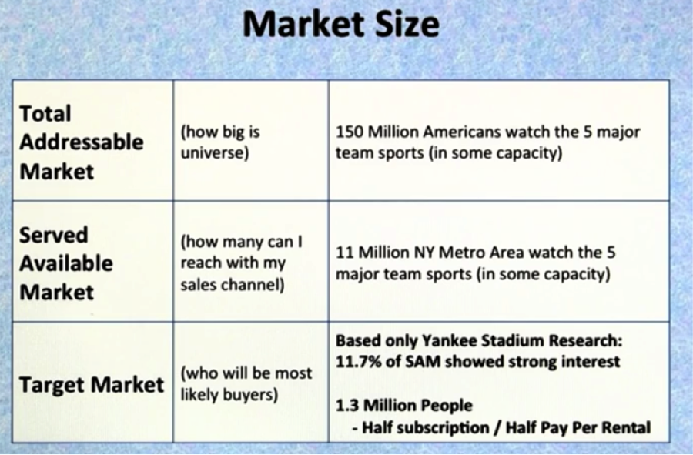
14- Market Size Summary:
- Talk to customers and sales channels
- Market size by competitive approximation
- Market Research firms (Forrester and Gartner, Wall Street Analyst Reports.)

15- Quiz:

16- JerseySquare Introduction:
- Case Study example for a rental service for sports jerseys.

17- JerseySquare Self-Intro:
- A JersySquare MVP Video

18- Quiz:

